The Quality Improvement (QI) Plan template is intended to provide LOHPs with guidance on developing a comprehensive QI Plan. Completion of a QI Plan is a required component of Objective 10, Activity 10.E.2 of the 2017-2022 workplan. QI coaching is also a required component of 10.E.1.

The QI Plan serves as an ongoing monitoring and evaluation tool for program, their partners, and their key stakeholders. QI Plans generally outline time-based and realistic goals and include related performance measures that are responsive to the oral health care needs of the community served and the strategic needs of the LOHP.

LOHPs that did not select Objective 10 are encouraged to complete a QI Plan for their programs in an effort to achieve measurable improvements in efficiency, effectiveness, performance, accountability, and other indicators of quality services being performed in their program.

How to Complete QI Plan Template
Please complete the following sections of the QI template:
- Executive Summary
- Mission, Vision & Values
- QI Management, Roles & Responsibilities
- QI Method
- Overall Goals and Implementation Plan for QI
- Project Selection
- QI Plan

You will find additional tools within this document to assist with developing the QI Plan. LOHPs are encouraged to use additional resources to develop a more comprehensive QI Plan. To view additional resources to include in your QI plan, click: Resources

QI Coaching: Please describe your experience providing QI coaching to primary care offices and community-based organizations (CBOs) on integrating “warm-handoff referrals” into their workflow.

How to Submit QI Plan
The QI Plan is due to the Office of Oral Health on or before July 31, 2022. You can submit your QI Plan and additional grant close-out materials by email to the Dental Director at DentalDirector@cdph.ca.gov. Please include your assigned Program Consultant and Grant Manager on your submission email.

Quality Improvement Template
<<<Insert name of LOHP>>> is committed to the continuous quality improvement of oral health services provided in <<<insert county, jurisdiction, agency name>. This QI Plan serves as the foundation of this commitment.

Executive Summary | The QI Plan is an important component of your LOHP’s commitment to the establishment of effective oral health care delivery and care coordination systems and resources; including workforce development and collaborations to serve underserved areas and vulnerable populations in your jurisdiction.  Briefly summarize the contents of your plan and what you have committed to doing to accomplish Objective 10. This summary can be written after the rest of plan is complete.
Mission, Vision & Values | Define your LOHP’s mission, vision, scope of service, and values. This should be consistent with what appears in your agency wide-documents, including your Community Health Improvement Plan (CHIP)/strategic plan.
Quality Improvement Management, Roles & Responsibilities | Describe how the quality improvement program will be structured and managed; structure is a required component of the plan. Consider whether you will have a formalized group to manage and prioritize the quality activities, or whether you will use an existing management structure, group, or committee.  Describe things such as:  - the organization, membership, and structure of the group  - the responsibilities of this oversight entity as a whole, and for each person/role,  - membership rotation,  - what types of support quality efforts receive (clerical functions, training, information technology, and/or technical assistance),  - outside resources and how they are used (specialists, consultants or trainers),  - frequency of meetings,  - budget and resource allocation

Quality Improvement Method | Name and briefly describe the quality improvement process you will utilize in your program.  For example:  - Plan Do Study Act (PDSA) Cycles. Plan-Do-Study-Act Worksheet (ahrq.gov)  - LEAN  - Process Mapping
Overall Goals and Implementation Plan for QI | State the frequency with which overall goals & objectives are determined and/or reviewed. Consider addressing overall agency-wide quality goals including culture, training, QI project support, and resources within your goals.  Show connections to your LOHP workplan. Objectives should be: Specific, Measurable, Achievable, Relevant, Time-based, Inclusive, and Equitable (SMARTIE). They may be capacity (Ex: By xx/xx/xxxx, Agency will have a LEAN-certified QI Coordinator.), process (Ex: By xx/xx/xxxx, Agency will establish a QI learner community for all county agencies participating in the County Shared Service Consortium.), or outcome (Ex: By xx/xx/xxxx, Agency’s QI projects will result in cost savings of at least $60,000 annually).
Project Selection | Describe how QI projects will be selected. Consider: Who will identify projects and how you will prioritize projects, identify team members, and address other specialized staffing that might be needed (such as support or data).  - Data Collection  - Data for Quality Improvement:  - Understand> How does the current system perform?  - Evaluate> Did our intervention result in improvement?  - Monitor> Is our improvement sustained over time?  - Data Collection Plan includes:  - Data elements and operational definitions.  - Collection method and data source.  - Due date.
QI Plan Logistics | Indicate how the plan will be tracked, reviewed, evaluated, and revised. Include the frequency in which these activities will take place. Link to your performance management system as appropriate.

QI Coaching: Please describe your experience providing QI coaching to primary care offices and CBOs on integrating “warm-handoff referrals” into their workflow.

A warm handoff occurs when one team member who has a relationship with the patient introduces the idea of the patient working with another team member, clearly explains why the other team member could better address a specific issue with the patient, emphasizes the other team member's competence, asks for the patient’s acceptance of the plan, and then "hands off" that patient to the other provider, either personally or via referral. When the original team member describes the other team member positively and tells the patient how the other staff member will help meet the patient's needs, the colleague is not only transferring trust to the other provider, but also helping the patient to see the team as a coherent, identifiable group.

Additional Quality Improvement Plan Tools & Resources

Developing a SMARTIE Objectives QI Project

This worksheet will walk you through the process of developing a Specific, Measurable, Achievable, Relevant, Time-based, Inclusive, and Equitable (SMARTIE) objectives. SMARTIE objectives are versatile and can be used for many purposes ranging from strategic planning purposes to quality improvement projects and Plan-Do-Study-Act cycles.

The following tables show an example of how to develop a SMARTIE objective and a table you can use to develop SMARTIE objectives for your QI Project.

Component | What it Means
Specific | Direct, meaningful, and detailed.
Measurable | Quantifiable progress toward goal achievement.
Achievable | Ambitious, but feasible given available resources  (e.g., time, money, personnel, tools)
Relevant | Aligned with team/organization mission.
Time-Based | Has a clear timeframe and deadline.
Inclusive | Brings traditionally marginalized people into the  process in a power-sharing way
Equitable | Includes an element of fairness to address  inequity and injustice.

SMARTIE EXAMPLE
To increase the number of pregnant women receiving dental care, Mt. Rose Dental Clinic will reduce the number of dental appointment no-shows among pregnant women referred by its Comprehensive Perinatal Services Program by 10 percentage points from the baseline (67%) by September 30, 2020, with at least 2% reduction among homeless women, as measured by Mt. Rose Dental Clinic’s appointment scheduling program.

Start Writing Your SMARTIE Goals
Use this template to write a goal for yourself or a team member.
Time Bound: My goals between (start date) and (end date) are to achieve this Specific and Achievable outcome:

I will know success when I see it using these Measurable standards:

A Realistic plan to achieve this goal includes these tactics/activities (consider time, resources, capacity):
By (date)
By (date)
By (date)
Thinking about Equity and Inclusion: Can you imagine there being any unintentional disparate impact along lines of power and identity? How might inequity or exclusion show up? For whom?

How could you change the goal to either mitigate that disparate impact or make Equity and Inclusion more explicit?

Plan-Do-Study-Act case study example:
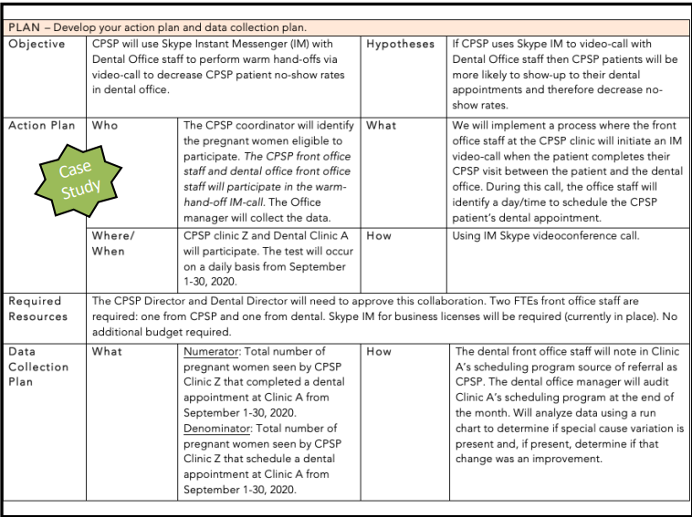

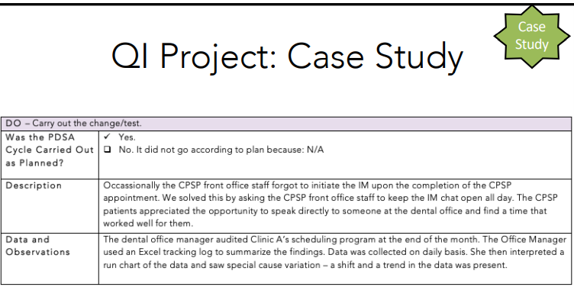
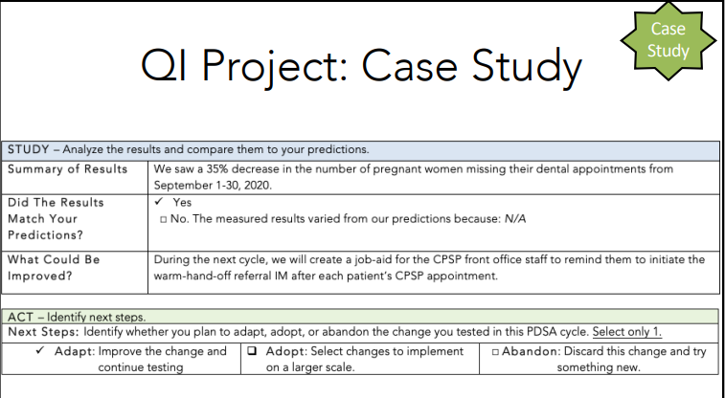

Process mapping, also known as a flow charts, workflows, or process flow diagrams, creates a visual picture of the sequence of steps in a process. Processes mapping helps us understand each step, the positions and people involved in each step, and the desired output. Making the process visible, simplifies the steps, improves efficiency, and decreases the opportunity for error.

This guide will help your quality improvement team develop a process map for your quality improvement project or PDSA cycle. Please note, you can develop a formal process map, using the symbols below, or you could do an informal map using stick notes and a sheet of paper. Do what works best for your QIP.

How to develop the Process Map
You can use any combination of the following materials to develop your process map: sticky notes or index cards, a large piece of flipchart paper or white board, pens or markers, or if you want to make it formal, Visio or PowerPoint.

- Map what the process IS currently, not what you’d LIKE it to be in the future or the ideal process
- Assemble a multifunctional team: involve people who have a variety of perspectives on the process.
- Decide the process is that you’re diagramming
- Determine the purpose of the process
- Define when the start and end points
- Decide how much detail you’ll include in your diagram
- Brainstorm what activities take place. Write each activity on a sticky note or card.
- Put the activities into the proper sequence (as you understand it)
- Draw arrows to show the flow
- Review your chart with others – clients, co-workers, other colleagues – to see if you need to add or change any steps

Adapted from the Institute for Healthcare Improvement, 2015.

Formal Symbols… if you want:

Process beginning or ending

Activity Step

Process flow direction

Decision point

Wait or delay

Swim lane (person responsible for step in process)

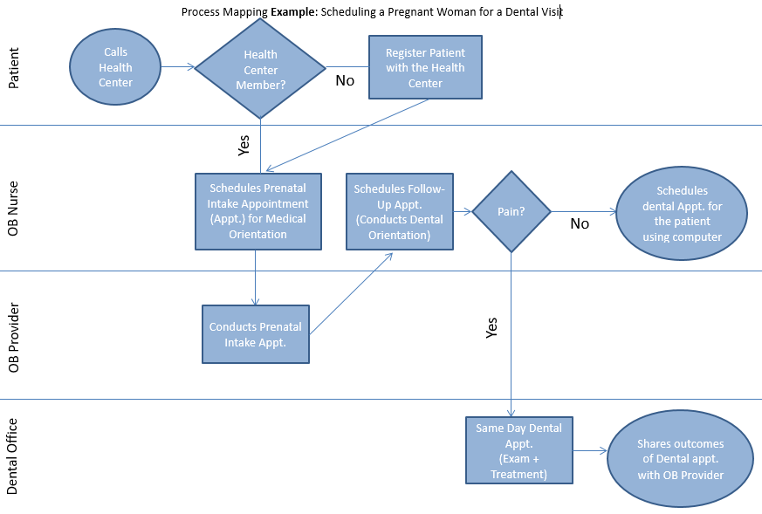

Example of Lean Methodology

Lean is a continuous quality improvement methodology used to streamline a process. Lean is time-tested and a free method used for identifying and eliminating wasteful steps in our processes. By eliminating waste, you can add value to the customer.

This guide will help your quality improvement team understand Lean principles so that you can review your process maps and eliminate waste.

Lean Philosophies
- Customer Focus – define value from the customer’s perspective and relentlessly drive out waste
- Respect – employees are central to value creation. Empower and engage employees to improve your products and services
- Data Driven Decisions – verify assumptions with data and make decisions based on analysis rather than anecdote
- Results – set ambitious SMART goals and measure results
- Accountability – hold yourself and others responsible for following through on commitment and shared results
- Excellence – strive to be the best, continually improve, experiment and learn from experience

Lean Principles
- Value-added: Any step in the process that improves the product for the customer
- Business Necessary: Activities ensuring that the value-added steps have been properly completed. These are steps required by law, regulation and/or policy. If they’re wasteful, you may consider changing the law, regulation or policy
- Non-Value Added: Activities that do not contribute to the product or the process and should therefore be eliminated. Non-value added steps are waste
Classic Forms of Waste: Eliminate OVERTIME
- Defects/Rework
- Overproduction
- Waiting
- Not Used Talent
- Transportation
- Inventory
- Motion
- Excess Processing

Why implement Lean?
Health Care is under increasing pressure to:
- Reduce waste and costs
- Increase productivity and services with less
- Improve processing time and quality of services
- Meet customer expectations
- Continuing to do business in the same way is not sustainable.
- Demand for services is increasing
- Resources are limited (natural, man-made, money)
Additional Resources:

American Society for Quality
The American Society for Quality offers a variety of online and in‐person training courses to help advance knowledge and application of quality improvement. Training costs vary.
https://asq.org/training/catalog#f:@freftopics86028=[Basic%20Quality
American Dental Association
The American Dental Association hosts the Dental Quality Alliance (DQA), which was established to develop performance measures for oral health care. The DQA hosts a variety of resources related to dental quality measures, educational resources, and improvement resources. Dental Quality Alliance | American Dental Association (ada.org)
Association of State and Territorial Dental Directors
The Association of State and Territorial Dental Directors links to a variety of evidence-based quality improvement resources. https://www.astdd.org/evaluation-and-quality-improvement/
Centers for Medicare and Medicaid Services
The Centers for Medicare and Medicaid Services issued a report for improving oral health care delivery in Medicaid and CHIP. The report is a toolkit to help states achieve the CMS Oral Health Initiative through QI. https://www.medicaid.gov/sites/default/files/2019-12/oral-health-quality-improvement-toolkit-for-states.pdf
Health Resources and Services Administration
The Health Resources and Services Administration published a report in 2011 explaining what QI is, why it’s important, the role of organizational leadership, how to prepare for change, the Model for Improvement, and other topics critical to QI. Quality Improvement (hrsa.gov)

National Association of County and City Health Officials
The National Association of County & City Health Officials has a compendium of Quality Improvement Training Resources. They also have tools to help assess QI maturity, develop a QI plan, provide QI training and resources to staff, prioritize and select QI projects and implement QI projects. http://qiroadmap.org/wp‐content/uploads/2013/01/QIRoadmap.pdf

https://www.naccho.org/uploads/downloadable-resources/QI-Plan.pdf

Public Health Foundation
The Public Health Foundation provides QI tools, training, and resources. QI Quick Guide: Welcome to the Quality Improvement (QI) Quick Guide (phf.org)
QI Tools: Quality Improvement Tools to Advance Public Health Performance (phf.org)

Prosci
Prosci’s AKDAR (Awareness, Desire, Knowledge, Ability, Reinforce) is a change‐management model that provides a framework for guiding individual and organizational change. As quality improvement inevitably demands a change in organizational culture and processes, AKDAR helps to “pave the way” for successful change. Costs vary. https://www.prosci.com
The Institute for Healthcare
Improvement hosts a variety of resources, tools, and trainings. Free Resources are available: http://www.ihi.org/resources/Pages/HowtoImprove/default.aspx

Free Tools are available (http://www.ihi.org/resources/Pages/Tools/default.aspx

The Dental QI Training, developed in collaboration with the Dental Quality Alliance, was the first QI training exclusively for dental professionals: http://www.ihi.org/education/IHIOpenSchool/Courses/Pages/Dental-Quality-Alliance-DQA.aspx
The Certificate in Quality Improvement courses: http://www.ihi.org/education/IHIOpenSchool/Courses/Pages/OpenSchoolCertificates.aspx
National Network for Oral Health Access
The National Network for Oral Health Access developed an operation manual for oral health programs; chapter six focuses on quality. Topics addressed in the toolkit include model for improvement, PDSA cycles, sample quality measures, case studies and more: https://www.nnoha.org/nnoha-content/uploads/2013/08/OpManualChapter6.pdf

