

Dental Assessment & Sealant Treatment Report

Today your child, participated in the School Smile Program at his/her school.
􀀀 Your child received a screening exam
􀀀 Your child received a fluoride varnish treatment.
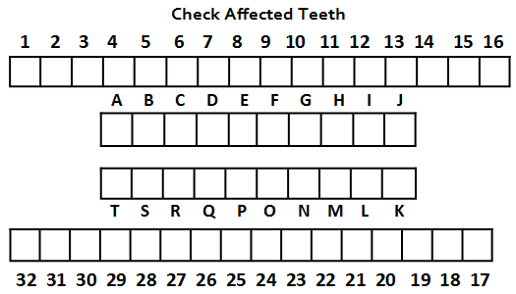
􀀀 Your child received _____ dental sealants today on teeth
L
R
R
A B C D E F G H I J
K L M N O P Q R S T
17 18 19 20 21 22 23 24 25 26 27 28 29 30 31 32
1 2 3 4 5 6 7 8 9 10 11 12 13 14 15 16
Primary Teeth
Secondary Teeth
L

At first, sealants can make the teeth feel too tall. The feeling might last until the normal chewing wears the sealant down into place.

If your child did not receive dental sealants today it was because:
􀀀 the teeth were not grown in enough to seal them
􀀀 the teeth were already sealed
􀀀 the teeth already had fillings because of decay
􀀀 the teeth were decayed – seek dental care
􀀀 the child was not cooperative
- the child does not have a signed YES consent on file with program
  - recommend sealants
*We will be returning next year and the need for sealants will be reassessed.

*Note: The dental screening does NOT take the place of a regular dental exam.*
It is recommended that your child see a dentist for:
􀀀 Emergency dental care – immediately
􀀀 Treatment of cavities – as soon as possible
􀀀 A regular dental exam with x-rays – as needed
􀀀 Dental cleaning is recommended

Provider: ____________ License #_____

**A regular dental check-up should occur every 6 months for most children. If your child needs dental care, please make an appointment with a dentist as soon as possible. If you have a current dentist please contact them for care. If your child does not have a current dentist or dental insurance, the program can assist you with this. A referral list is on the back or you can call us at:

Dental Office | Contact info | Medi-Cal | Languages Spoken
Santa Rosa Junior College Dental Hygiene Clinic  Open during:  Spring Semester (Jan-May)  Fall Semester (August-Dec.) | 1501 Mendocino Avenue  Santa Rosa, CA 95401  707-522-2844 | No  *A $40 fee for a regular cleaning  *A $35 fee for x-rays if needed | English and Spanish
WIC Dental Days  Dental visits for children 0-5yrs old ONLY | 1450 Guerneville Road  Santa Rosa, CA 95403  707-565-6590 | Yes | English, Spanish and American Sign language
St. Joseph Dental Clinic | 751 Lombardi Court  Santa Rosa, CA 95407  707-547-2221 | Yes | English and Spanish
Santa Rosa Community Dental Center | 1110 North Dutton Ave  Santa Rosa, Ca 95401  707-303-3395 | Yes | English and Spanish
Sonoma County Indian Health- Dental Clinic | 144 Stony Point Rd  Santa Rosa, CA 95401  707-521-4500 | Yes | English and Spanish
Russian River Dental Clinic | 16319 3rd Street  Guerneville, CA 95446  707-869-2933 | Yes | English and Spanish
Petaluma Health Center  Dental Office | 1179 N. McDowell Blvd.  Petaluma, CA 94954  707-559-7550 | Yes | English, Spanish, Korean, Vietnamese, Eritrean
Rohnert Park Dental Center | 5900 State Farm Dr  Rohnert Park, CA 94928  707-559-7602 | Yes | English and Spanish
Alliance Medical Center  Dental Clinic | 1381 University Street  Healdsburg, CA 95448  707-433-5494 | Yes | English, Spanish and Persian
Sonoma Valley Community Dental Center | 19270 Sonoma Highway  Sonoma, CA 95476  707-939-6070 | Yes | English and Spanish
Alexander Valley Dental Center | 100 West 3rd Street  Cloverdale, CA 95425  707-894-2094 | Yes | English and Spanish
Redwood Empire Dental Society (REDS) | Martin Van Tassel  1400 N Dutton Ave, Suite 10  Santa Rosa, CA 95401  707-546-7275 | Contact Martin at REDS if you are interested in a referral for private dentists.

