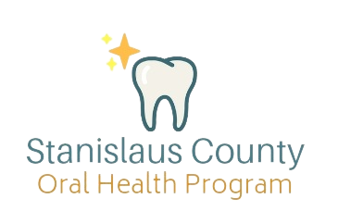
[Insert date here]
Re: Kindergarten Oral Health Assessment

Dear Mr. Lattig,

According to the American Academy of Pediatrics, early childhood caries (ECC) or tooth decay is the most common chronic disease in children, surpassing asthma, obesity, and allergies. Children cannot learn when they are in pain, sleep-deprived, or distracted because of tooth decay, making ECC one of the leading causes of chronic absenteeism. ECC is highly preventable, and Ceres Unified School District can help ensure all students have the opportunity to thrive by supporting preventive dental care efforts.

In 2006, California created the Kindergarten Oral Health Assessment (KOHA) to improve school readiness and raise families’ awareness of the importance of oral health. State law (AB 1433) requires that children receive a dental check-up by May 31 of their first year in public school (TK, kindergarten, or first grade). School districts must report KOHA data in the System for California Oral Health Reporting (SCOHR) by July 1 each year.

Attached you will find a KOHA report card for Turlock Unified School District which shows positive progress –30% of schools reported data into SCOHR for the 2023–2024 school year. However, only 38% of students received a KOHA dental check-up, and 30% were identified as having dental decay, with 10% requiring urgent dental care. Several low KOHA completion rates, with most below 50%, and moderate “no response” rates, indicating an opportunity to strengthen participation and reporting across the district.
To support your schools in improving KOHA completion and reporting, the Stanislaus County Oral Health Program has developed a KOHA Toolkit. This resource provides schools with easy-to-use forms, parent outreach materials, and tips for collecting and aggregating data for SCOHR submission. By increasing participation, we can help ensure that children with unmet dental needs are connected to care early, reducing absenteeism and supporting academic success.

To access the KOHA Toolkit please visit: https://www.schsa.org/PublicHealth/mainpages/oral/

We would welcome the opportunity to meet with you to discuss ways the district can further improve KOHA participation rates and address barriers to reporting. Together, we can ensure that every child in CUSD has a healthy start to their education.

Thank you for your commitment to the health and success of your students.

Sincerely,
Stanislaus County Oral Health Program

