
KOHA Starter Manual for School Staff and Local Oral Health Programs

[TEXT BOX]
[TEXT BOX]

About This Manual

A Note to LOHPs

This Kindergarten Oral Health Assessment (KOHA) “starter manual” was developed by other LOHP staff as a tool to provide a template for KOHA language that other LOHPs can use in developing their own county-specific KOHA manual or toolkit to present to school staff.

In creating this manual, we referenced existing LOHP handbooks and valuable feedback from school nurses. LOHPs can use this manual “as-is” by adding county-specific information and resources. LOHPs may choose what is most helpful, insert LOHP-specific documents, or utilize personalized graphics/visuals as needed. The Appendices provide additional resources for implementing KOHA, which LOHPs can also customize.

We purposefully created this manual in Microsoft Word format to easily copy, paste, edit, or customize content. Areas where LOHP-specific instructions or content should be added are highlighted in red. Direct linkages to websites are embedded for your convenience.

Although this manual is intended explicitly for school staff use, we realize some may wish to develop additional KOHA instructions and tools for internal LOHP staff or external partners separate from this document.

We hope many find this starter manual a useful resource.

Sincerely,
School Dental Program Workgroup Resources Subcommittee, 2023-2024

How to Use This Template

[Delete this page before providing it to school staff]

Easy-to-Use Template

- Best viewed side-by-side on the DESKTOP version of Microsoft Word
- Auto-populated Table of Contents and Navigation pane; see “References” tab above
- 4 Style buttons pre-formatted; see “Current Font Styles and Spacing” on next page.

3 Useful Tools to Cut and Paste (Optional Use)

- Section divider or for page headers:

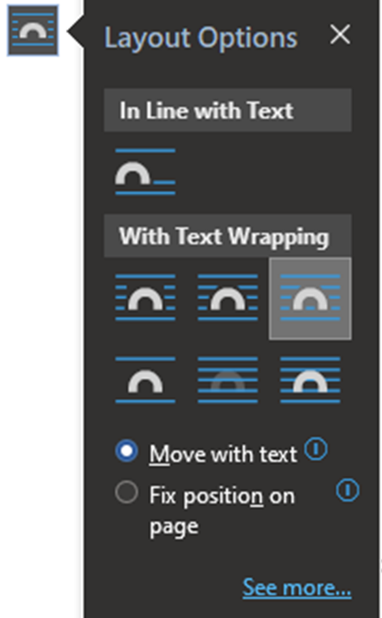
- Expandable call-out/text box to cut and paste for emphasis when needed:
for emphasizing or reminding
can be used with or without an icon
pre-formatted, right justified, small caps, 11 pt

[Delete this page before providing it to school staff]

3. Simple MS Office icons to use as you see fit:
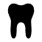


Style Guide (Current Font, Style, and Spacing)

- Font: is Century Gothic in Black/Automatic color unless hyperlinked
- Styles: The first 4 buttons below in the “Styles” pane screenshot are pre-formatted for the manual. (See image of style pane circled below.)
- Size, spacing: To help make your document more ADA accessible, please use at minimum: 12pt font, 1.5 spacing, and limit italics. Formatting heading style also helps readers navigate the document.
- Navigation: To check your work with heading styles, click “View” at the top of the page, then check the box at “Navigation Pane.”
- See style guide below for this version:
Page Headers – 26 pt Bold
Page Subheadings – 16 pt Bold
Body – 12 pt, usual spacing 1.5
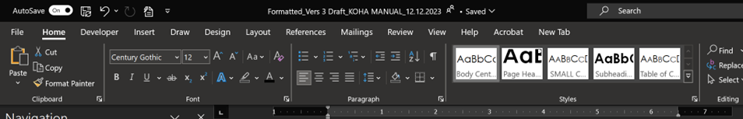
Table of Contents (TOC) – 14 pt

[Delete this page before providing it to school staff]

Notes for Editing

- 2 pages as a guide on how to use this template
- This is just a guide; efforts were made to help make it simple and with as much useful info as possible
- You can tailor it to fit your county or school’s needs
- Microsoft Word can be scary, but it doesn’t have to be
- Several You Tube videos that show MS Word in step by step depending on your task, but tried to include as much helpful info as possible to help get you started
- Play around with it, practice makes it easier
- The few first pages should be thoroughly read to understand how we put the document together
- If you run into issues, reach out to COHTAC our partners
- WHEN ALL ELSE FAILS – CUT AND PASTE

The 3 most common tabs are: HOME, REFERENCES, and VIEW tabs

KOHA Key Contacts

LOHPs: Your Local Oral Health Program staff can provide information, resources, and trainings about KOHA. Please contact your LOHP with any KOHA questions.

- [Insert LOHP contact info]
- [Insert LOHP KOHA webpage if applicable]

SCOHR: The System for California Oral Health Reporting (KOHA database) is how we track the KOHA data locally and statewide. In addition to your LOHP staff, SCOHR staff can provide help with SCOHR-related questions and needs.

- Email: scohr@sjcoe.net
- Phone: (866) 762-9170
- SCOHR/Ab1433.org webpage

COHTAC: The California Oral Health Technical Assistance Center collaborates with LOHP staff, SCOHR staff, and the California Department of
Public Health’s Office of Oral Health to provide technical assistance to LOHPs.

- Email: oralhealthsupport@ucsf.edu
- COHTAC website
- COHTAC KOHA webpage

Useful Links

- COHTAC KOHA main webpage
  - Contains link to this manual
- KOHA updated forms – English and multiple languages
- KOHA FAQs
- SCOHR information, User Manual, and FAQs

Table of Contents

[After editing and customizing manual, these page numbers will need to be updated accordingly]
About This Manual 2
How to Use This Template 3
KOHA Key Contacts 6
KOHA Overview 9
KOHA Implementation 15
Reporting KOHA Data into SCOHR 26
Running Reports in SCOHR 37
Tips and Promising Practices for Implementing KOHA 40
Frequently Asked Questions (FAQs) 42
Appendices 46

KOHA Overview
The Problem

Tooth decay is the most common preventable chronic childhood disease. However, by third grade in California, more than 60% of students have experienced tooth decay. Children with poor dental health are nearly three times more likely to be absent from school. According to the California Department of Education, dental problems contribute to 874,000 missed school days yearly, costing schools over $29 million annually in average daily attendance funding. If left untreated, tooth decay adversely affects children’s academic performance, social-emotional development, sleep, and nutrition, leading to poor general health outcomes.

In [--------------] County,
[Add local data, if available.]

California State Requirements

The Kindergarten Oral Health Assessment (KOHA) requirement was passed into law under the Education Code Section 49452.8 and updated in 2024 by Assembly Bill (AB) 2630, effective January 1, 2025. This new legislation clarifies the existing KOHA requirement will now apply to children enrolled in Transitional Kindergarten (TK). As a result, TK students will be included in KOHA, to ensure earlier oral health screening and intervention.

For schools and Local Oral Health Programs (LOHPs), this change means that efforts to promote KOHA and school dental programs should now include TK students in their outreach and services.

As EC 49452.8 now includes TK in the definition of “kindergarten,” the California Department of Education (CDE) recommends that TK students be treated the same as kindergartners. EC 49452.8 also provides that proof of the KOHA screening shall be required only once during a two-year kindergarten program.

The original legislation also requires specific KOHA data be collected by school staff annually and submitted to the County Office of Education. The database developed for KOHA data is called the System for California Oral Health Reporting (SCOHR). For reporting purposes under this section, TK students will be counted with the kindergartners and will not be reported as a separate age group in SCOHR. When filling out the KOHA form, enter TK, K or 1st Grade.

In 2017, Senate Bill 379 (SB 379) was passed, allowing schools to use passive consent at oral health screening events at schools. This means every child will receive a screening if offered at their school unless their parent/caregiver signs a letter asking that their child not receive the screening (opting out).
The KOHA screening is:
- Free
- Quick (usually around two minutes)
- Generally conducted at the child’s regularly scheduled dental appointment
- Not a complete oral health examination or evaluation
- Not used to provide any dental diagnoses for the child
- To be completed and turned into the school as close to the beginning of the school year as possible
- Due to the school before the end of the school year (or by May 31st, whichever comes first)

Supporting the KOHA requirement is a simple way schools can promote children’s readiness and success by identifying children suffering from untreated dental disease and helping parents/caregivers establish a dental home for their children.

Schools and Grade Levels for KOHA Requirement

The KOHA requirement applies to all California public schools with kindergarten grade levels, including public charter schools.

- Transitional Kindergartners and Kindergartners: All public-school children entering the kindergarten grade level must complete the KOHA requirement. In 2024, AB 2630 defined “kindergarten” as transitional kindergarten and kindergarten. The screening is only required once in the two-year period covering transitional kindergarten or kindergarten.
- First graders not previously enrolled: Some children do not attend public school Kindergarten. Their first year in public school is first grade. Therefore, the oral health assessment is only required for first-grade students entering public school for the first time—not all first graders.

Role of School Staff

Oral health is an integral part of the overall health of children. Schools and school staff play a crucial role in reducing dental disease among children by raising awareness of the importance of oral health and helping connect children to a dental home.

Role of Parents and Caregivers

Parents and caregivers can complete the KOHA requirement by taking the KOHA form to their child’s regularly scheduled dental appointment. The dental provider will complete the form. Once completed, the parent or caregiver returns the form to the school.
Another way to complete the requirement is to have the child screened and the KOHA form completed by licensed dentists or dental hygienists at school or a community event.
Steps to KOHA Completion for Parents/Caregivers:

- Receive the KOHA form from the school.
- Schedule the child’s dental appointment. Or, if the school is hosting an on-site oral health screening day, the child can be screened at that event.
- Bring the form to the child’s next scheduled dental appointment. The licensed dental professional will complete the KOHA form for free at the appointment and schedule any follow-up appointments needed.
- Return the completed KOHA form to the school and take the child to any follow-up appointments. While technically, the forms can be turned in until May 31st (or before then, for schools that get out before May 31st), parents/ caregivers should turn in the forms as close to the beginning of the school year as possible.
*See shareable graphics of these steps in English and Spanish in the KOHA social media toolkit here.

Role of Local Oral Health Programs (LOHPs)

As oral health liaisons, LOHPs can make a difference by assisting both parents/caregivers and schools with the KOHA completion process. Educating and mentoring school nurses, teachers, and staff about the KOHA requirement and steps to completion are important ways LOHPs can help. *See Appendix A for a sample letter to the Board of Education about KOHA.

Raising Dental Provider Awareness

Dentists and dental hygienists are continuously informed about the KOHA requirement and their role by various entities: dental professional associations, local dental societies, dental managed care plans, Medi-Cal Dental, and the
Local Oral Health Program (LOHP) staff. The dental office may or may not have KOHA screening forms on file.

Raising KOHA awareness among dentists and dental hygienists is ongoing. This includes asking dental offices to have blank KOHA forms on file for clients who are Kindergarten public school students. More information about KOHA for dental professionals is available on the California Dental Association webpage.
Some dental professionals or dental clinics have already contracted with school districts to provide on-site oral health screenings or other preventive oral health services, like fluoride varnish or sealants, at select schools. In order to provide these services at schools, the dental provider must complete a Memorandum of Understanding (MOU) or other contract with the school district. The Local Oral Health Program also may have an MOU with the school district to assist with providing on-site oral health services. Contact your LOHP or school district staff to learn more about existing on-site oral health services provided at schools in your county.

Funding Sources for KOHA Activity Support

Local Control Funding Formula (LCFF) and Local Control and Accountability Plan (LCAP):
KOHA funding can be included through the Local Control Funding Formula (LCFF). Schools are urged to include KOHA activities when developing their Local Control and Accountability Plan (LCAP). These funds can be used to notify parents/ caregivers of the oral health assessment requirement, coordinate on-site oral health screenings, and report data. Implementing the KOHA requirement directly or indirectly impacts two of the eight LCAP priority areas—Student Engagement and School Climate.

a. Student Engagement- a key measure of student engagement is chronic absenteeism. Research shows children with poor dental health are nearly 3 times more likely to be absent from school.

b. School Climate - measures of school climate include whether students have access to proper resources and feel cared for and whether school staff can assist and promote a healthy school environment. Linking students to oral health care and a dental home through the oral health assessment requirement positively impacts these measures.

CalAIM Community Health Worker Benefit: This benefit can be used to hire Community Health Workers (CHWs) to do care coordination activities for KOHA. Your LOHP staff or other organizations may be partnering with CHWs to utilize this benefit for KOHA-related purposes. More information here.

KOHA Implementation

School and district staff should work together to assign roles and responsibilities for each step of the KOHA process, outlined below. The following steps are also provided in a timeline and checklist format in Appendix B here, and on COHTAC’s KOHA webpage: KOHA Sample Timeline and Checklist for Schools.

Step-By-Step Guide

KOHA process OVERVIEW flowchart--editable, customizable
KOHA process flowcharts for various audiences--editable, customizable


STEP 1 - KOHA Forms
………………………………………………...………………Update and Distribute

The following KOHA forms should be sent to parents/caregivers in the TK and kindergarten registration packets. *Some districts are moving away from paper registration packets. In these districts, the KOHA forms should be uploaded to appropriate webpages or portals for parents/caregivers of students. Web links to each KOHA form are also available, as shown below.

The TK and kindergarten registration packets are usually prepared by district-level staff the year before the current school year, and KOHA forms should be included in this packet. Please work with district staff to determine whether KOHA forms were included in the transitional kindergarten and kindergarten registration packets. If not, please work with LOHP and district staff to ensure KOHA forms are included in the TK and kindergarten registration packets, and send the KOHA forms out to all parents/ caregivers of TK and Kindergarten students as soon as possible.

Other KOHA form distribution opportunities include TK and kindergarten orientation and back-to-school nights.

IMPORTANT: If your school or district is still using the older KOHA forms, please discontinue their use as soon as possible and use the updated forms listed below.

Key Updates to KOHA Forms, Revised in 2022

- Forms were revised to include more information about whether children with urgent dental care needs received follow-up care. Since a primary goal of KOHA is to connect children to a dental home (a regular source of dental care), this section helps schools and LOHPs ensures students are getting the care they need.

- A more detailed waiver form that is separate from the KOHA form discourages easy waiving when a screening could be completed for the child. More information is now included to learn why parents/caregivers may waive, so LOHP staff can work with school staff and community partners to address those barriers.

- New school-based screening opt-out letter for students at schools receiving on-site school oral health screenings. Should a
parent or caregiver choose not to have their child screened at school, they will sign this opt-out letter.

Online Links to Updated KOHA Forms

- All KOHA forms in English and multiple other languages (Chinese, Korean, Spanish, Tagalog, Vietnamese)
- Parent Notification Letter
- KOHA Assessment Form
- Waiver of KOHA Requirement
- On-site Screening Opt-Out Letter

- Parent Notification Letter - describes what the KOHA requirement is and what parents/caregivers need to do. It includes information about how to access dental care in the county, as well as basic oral health information.
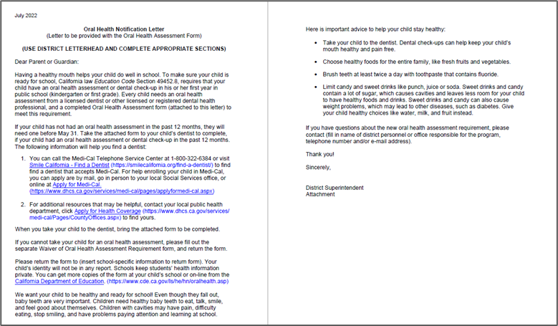

- Kindergarten Oral Health Assessment Form – the screening/assessment form parents/caregivers need to take to their child’s dental appointment and have the dental provider complete. If the child’s school hosts a KOHA screening day, the dental providers will complete this required form there.

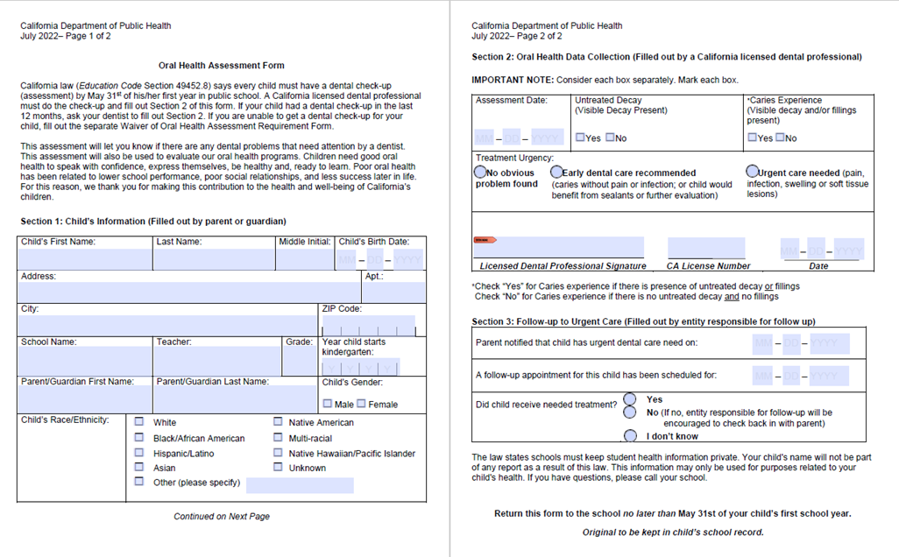

- Waiver of the KOHA Requirement - if children do not yet have a dentist or dental insurance, cannot easily get to a dentist, do not attend a school hosting an on-site KOHA screening event, or their parent/caregiver does not believe they would benefit from the assessment, a waiver form may be completed. However, if parents/caregivers need further assistance to complete the KOHA, they are encouraged to contact their school health staff or Local Oral Health Program.
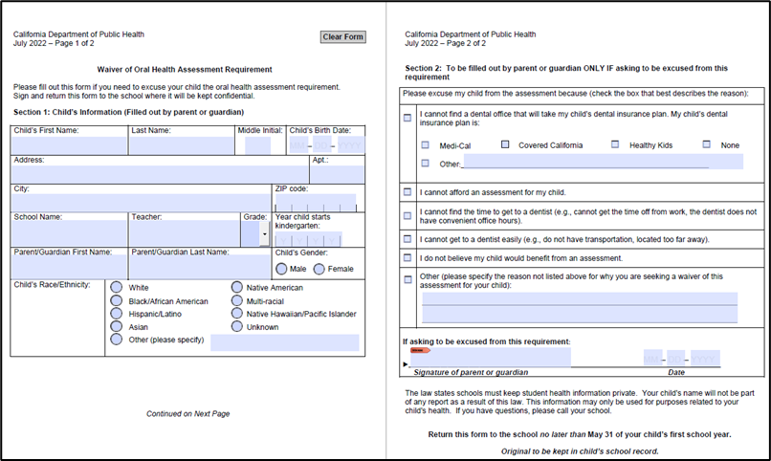

- KOHA On-Site Screening Opt-Out Letter (For schools hosting on-site screenings)- This letter only goes to parents/caregivers of students at schools receiving on-site screenings, and is a way they can let schools know they would not like to have their child receive the free on-site oral health screening. If this letter is included in the KOHA forms packet for schools that
do not host on-site screenings, parents/ caregivers may confuse it with the KOHA waiver form.
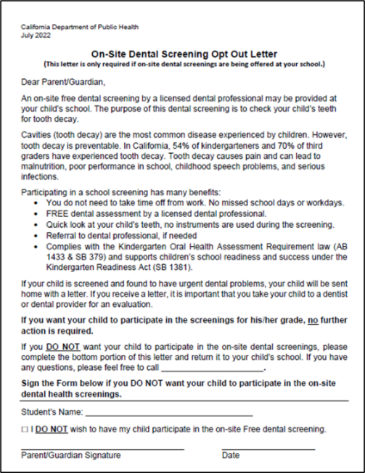

Additional Forms

The KOHA screening results letter for parents/caregivers is an additional site-specific form for on-site KOHA screenings. It is completed by the dental provider for each child receiving an on-site school oral health screening. It is sent home to parents/caregivers and includes information about the basic findings and any next steps needed.
*See Appendix C.1 for a sample screening results letter in English (web link here). *See Appendix C.2 for the sample screening results letter in Spanish (web link here).


STEP 2 - Reminders
…………...……………………………..……Provide to Parents and Caregivers

Until the end of the school year or May 31st, whichever date comes first, send at least three reminders to parents/ caregivers who have yet to return KOHA forms. *See Appendix D.1 for a sample reminder letter template in English (web link here).
*See Appendix D.2 for a sample reminder letter template in Spanish (web link here).
*See Appendix E for a sample KOHA flyer template (web link here).

[Link any other sample reminder letters/ KOHA flyers created by LOHP here]

- If your school hosts on-site screenings: prior to the oral health screening day, a letter is usually sent to parents/ caregivers informing them of the details of the screening day. It should also provide instructions about how to opt-out of the screening, or include the “On-Site Screening Opt-Out Letter” linked above. [Insert local process info. about on-site screenings if different from the info. in this paragraph].


STEP 3 – Data
.…………………………………………. Continually Collect and Track Data

Each school is required to track, tally, and report specific data from the KOHA forms for each child eligible for KOHA. The forms are collected and tracked continuously throughout the school year.

- If your school hosts on-site screenings: Completed forms from the screening day are given to school staff by the dental screening provider/organization.

- The data is reported into a database called the System for California Oral Health Reporting (SCOHR) at the end of the school year, or by July 1st at the latest (see “Reporting KOHA Data into SCOHR” section below for more details about tracking, tallying, and entering data into SCOHR.)


STEP 4 – Referrals
………................................................................Urgent Dental Needs Follow-Up

On the completed KOHA screening form (Section 2), there are three “treatment urgency” levels:

1 - No obvious problems found
2 - Early dental care recommended
3 - Urgent care needed

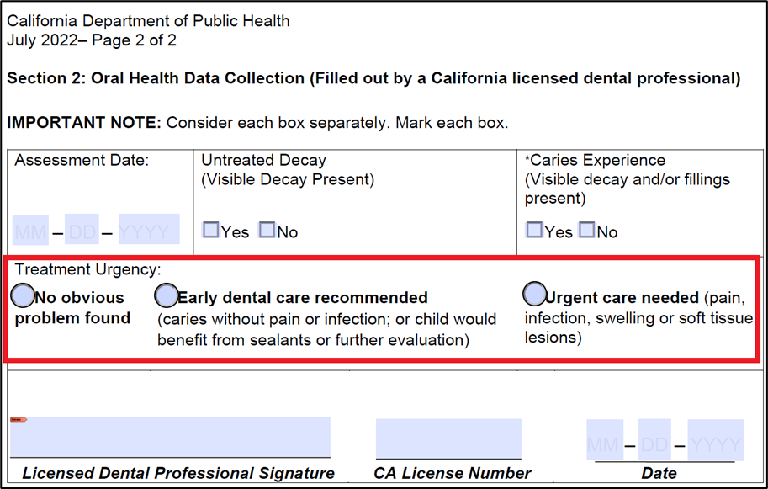

Treatment Urgency Definitions

1 - No obvious problem found - The child has no obvious dental problems and should continue to have routine examinations by their dentist every six months.
2 - Early dental care recommended - The child has a tooth or teeth that have decay and should be checked by their dentist. They may benefit from sealants. The child’s parent/guardian should contact the child’s dentist, who will determine whether treatment is needed.
3 - Urgent care needed - The child has a tooth or teeth that appear to need immediate care, as there is pain, infection, or swelling. The child’s parent/guardian should contact the child’s dentist as soon as possible for a complete evaluation.

The KOHA process requires follow-up for students with the highest level of treatment urgency - urgent dental care needs. This information is recorded on Section 3 of the KOHA form:
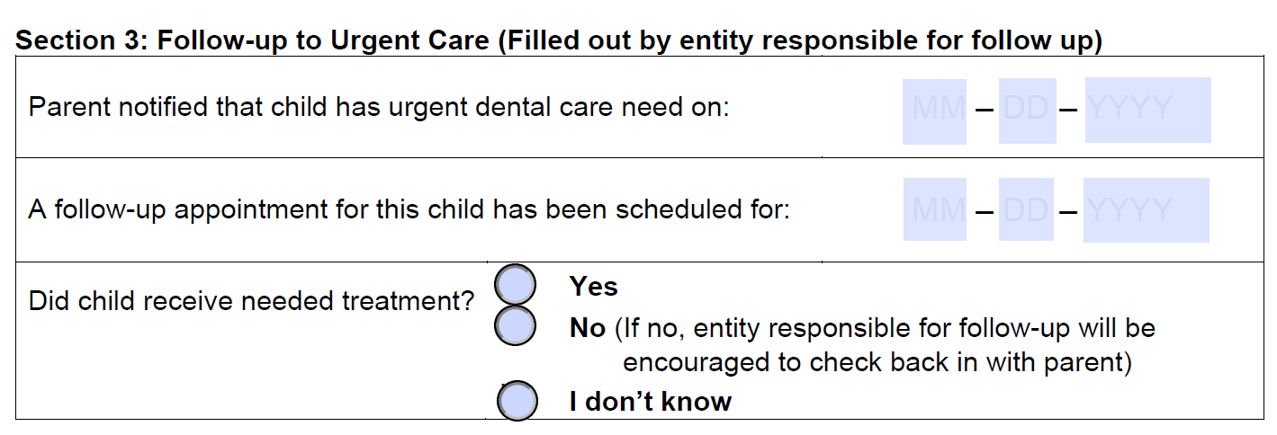
it is very important to follow up with
Children with URGENT DENTAL CARE NEEDS, as
they should receive follow-up care immediately

- For children receiving the screening at their dental office: the dental office should address the urgent care need, and inform the parent/caregiver of next steps, including scheduling a follow-up appointment. They may provide the needed treatment that same day. The dental office should complete these parts of Section 3 of the KOHA form. If the child didn’t receive needed treatment the same day as their screening, school staff—if able--should follow-up with parents/caregivers to see if the child received needed treatment. School staff [or insert county-specific guidance about what who should do this follow up] will then complete this part of Section 3 of the KOHA form.
- For children receiving the screening at their school: because the dental screeners complete a “screening results letter” (*See Appendix C.1 and C.2) for parents/caregivers of children screened, they should complete the “notified parent” part of Section 3 on the KOHA form. However, it is likely school staff [or insert county-specific guidance about what who should do this follow up] will need to follow-up with parents/caregivers to see if a follow-up appointment was made for the child, and if the child received needed treatment. School staff [or insert county-specific guidance about what who should do this follow up] will then complete these parts of Section 3 on the KOHA form.
- [If the county has a dental referral management system: include all referral management system instructions for school staff if your county already has one, or when the state system is ready. Include instructions about who does follow up and care coordination and how. Consider including dental access resources or links to these resources here, and/or as an Appendix item.]

STEP 5- Waiver Forms
...............................................................................Waiver Form Follow-Up

For students who returned a signed KOHA waiver form:
[Insert county-specific guidance on what to do, if anything, to follow-up with students that returned a waiver form.]

The waiver form (Section 2 of the waiver) asks parents/caregivers to list the reason they waived.

- If parents/caregivers mark the following reasons for waiving, school staff can provide resources and additional information about how to access a dentist, enroll in Medi-Cal health and dental insurance, use the Medi-Cal transportation benefit to get to a dental appointment, etc. Contact your Local Oral Health Program to obtain this information if you do not already have it:

- Cannot find a dental office that accepts my child’s dental insurance plan
- Cannot afford an assessment for my child
- Cannot find the time to get to a dentist
- Cannot get to a dentist easily

- Many parents/ caregivers mark “I do not believe my child would benefit from the assessment” as the reason for waiving. If this is the case, additional education and awareness raising is likely needed for parents/caregivers and school staff about why KOHA is important for children’s oral and overall health and engagement in school. Contact your Local Oral Health Program staff to see if they can provide educational sessions about KOHA, additional resources, or other information.

- Some parents sign the waiver form because their child already has a dental home and sees a dentist regularly, so they do not feel the need to bring the KOHA form to their child’s dentist and have them complete it. Please remind them that the KOHA is a statewide mandate that needs to be completed and submitted to the school. They will need to bring the KOHA form to their child’s next dental appointment and have the dental provider complete it.

Reporting KOHA Data into SCOHR
System for California Oral Health Reporting (SCOHR) Database

About SCOHR

The System for California Oral Health Reporting (SCOHR) database was developed to provide a centralized online method of entering all required KOHA data. This section contains detailed information about how to use SCOHR.

ALL KOHA DATA FOR THE SCHOOL YEAR
IS DUE IN SCOHR BY JULY 1ST AT THE LATEST

- A more detailed SCOHR User Manual developed by SCOHR is available here.
- The webpage on COHTAC about SCOHR, including SCOHR FAQs, is linked here.
- Appendix F is an infographic summarizing the key ways to enter data into SCOHR (web link here).

Becoming a SCOHR User

Become a SCOHR user to report the required data into the SCOHR database.
To get a username and password to become a SCOHR user, go to the SCOHR website, and click on the “Sign Up” tab at the top right of the navigation bar, and select your County and District from the drop-down menus.

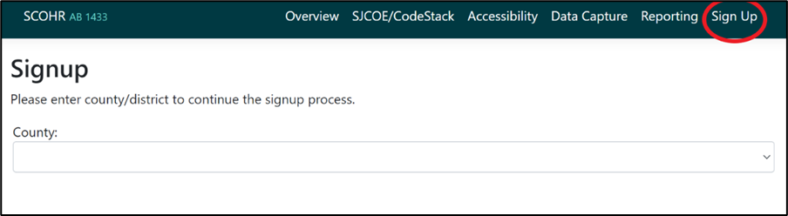

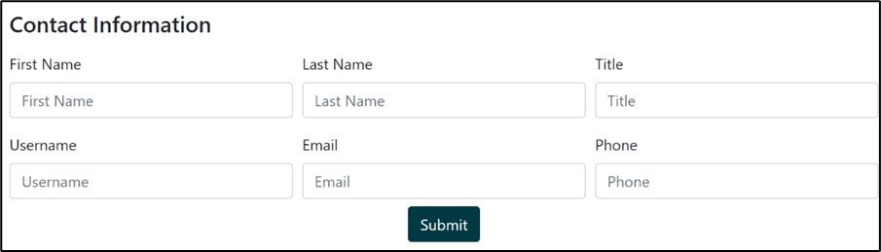

If SCOHR Contact Information is Blank
If the “Contact Information” section for the district is blank as shown above, fill in your information to become a SCOHR user. You will create your username. After clicking “Submit,” the pop up message from SCOHR will provide you with further instructions. An email will be sent from noreply@ab1433.org with the subject, “Ab1433.org new user account created.” Open that email and click on the link to set up your password. You must set up your password within a day, or the link expires. Check spam, junk, and other folders for the email from SCOHR.
NOTE: If the “Contact Information” section already has a name entered, email or call SCOHR to be set up as an additional user for the school or district.

Types of SCOHR User Accounts Available for School Staff

If you call or email SCOHR to become a database user, they may ask you what user level you want--school or district:
- School user – report and edit data exclusively for one school. Summary reports include data from just the one school.

- District user – report and edit data for multiple school sites. Summary reports include data from all schools in the district.

SCOHR Help Contact Information
Email: scohr@sjcoe.net
Phone: (866) 762-9170

Forgotten Username or Password

If you are a current SCOHR user, but have forgotten your credentials for logging in to SCOHR:

Click the “Forgot Password” link under the sign in section on SCOHR’s main page. You will be asked to enter in the email associated with your account. After submitting your email, you will receive an email from “SCOHR” (noreply@ab1433.org) with the subject: “Ab1433.org Forgot Password.” Sometimes it takes a few hours for the email to arrive. The email will contain your username, and a link to create a new password. The email link to create a password expires, so reset your password immediately after receiving the email.

If you have multiple SCOHR accounts associated with the same email, you will receive a separate email for each account, each containing your username and a link to set up a new password for that account.

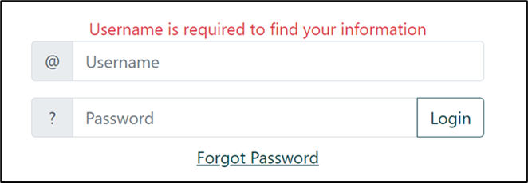

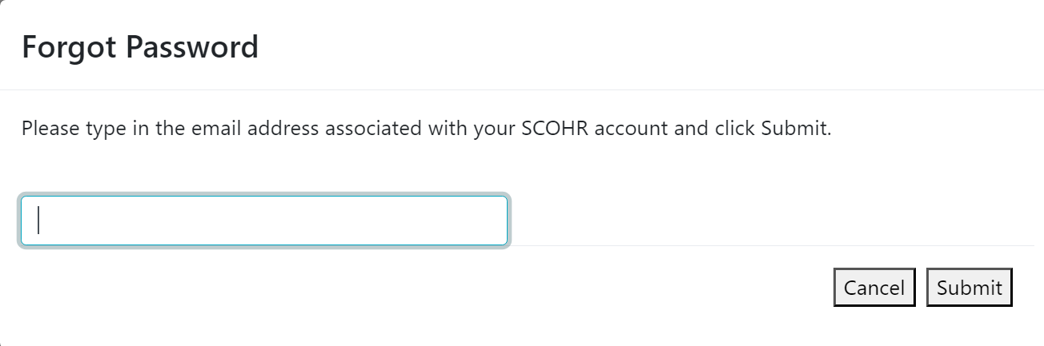
NOTE: If you click the “Forgot Password” link and enter in your email multiple times in a row, when you check your email, make sure to look for the most recent email from SCOHR. The password reset link in any older emails from SCOHR will not work.

KOHA Data Entry in SCOHR

[This section is long. Included in it are the two different ways to enter aggregate data in SCOHR, so that LOHPs can customize this section based on the method/s they use. You can delete whatever does not apply to how your county or school districts enter data into SCOHR. For example, if your schools and districts only enter in aggregate data using the Data Input Form, delete the section about bulk upload].

- Aggregate Level SCOHR Data Entry
(For “Non-Participating” Schools/Districts)

Aggregate data entered comes from:

- Sections 2 and 3 of the KOHA form
- Section 2 of the waiver form
- Signed on-site screening opt-out letters
- Enrollment data

Aggregate level data may be entered into SCOHR in two ways. Please work with your Local Oral Health Program staff to determine which option to use for your school/district:

- SCOHR Data Input/ Quick Data Input Form: to enter the required 20 data fields into SCOHR, one school at a time.
- SCOHR Bulk Upload/ Upload function: to enter the required 21 data fields into SCOHR, for multiple schools at a time.

- SCOHR Data Input / Quick Data Input Form (aggregate level data)

Data Collection Tools:
An Excel spreadsheet and a fillable PDF are two tools available to assist school staff. The aggregate data totals from these tools are then entered into the SCOHR Data Input/ Quick Data Input Form in the database.

- KOHA SCOHR Data Input Form Excel Worksheet:
(Tabs on the Excel Worksheet are located at the very bottom of the Worksheet): [Tabs 1, 3, and 4 of these worksheets are locked and cannot be edited. If your LOHP would like to edit these tabs, please email COHTAC for the password to unlock those sheets.]

- (Tab 1): Instructions- provides basic instructions on how to enter data and use each tab. Also includes a link to the instructional video that accompanies the Worksheet on the COHTAC KOHA Data webpage.
- (Tab 2): KOHA Data Entry Worksheet - As students return KOHA forms during the year, track each student’s required data on this tab
- (Tab 3): SCOHR Data Input Form format- this tab automatically puts all the data from the first tab into the same format as the SCOHR Data Input Form (the 20 data fields). No data entry is required on this tab. These totals can then be copied and entered into SCOHR. Data checks on this tab assure data is corrected before submitting to SCOHR.
- (Tab 4): Data Summary – this tab automatically pulls the data from the other tabs and puts it into a table and graphs to summarize the key KOHA data. No data entry is required on this tab.

- SCOHR Data Input Form (Fillable PDF) With Color-Coded KOHA "Maps:” An alternative to using the Worksheet above. Enter data already totaled into this fillable PDF form (20 data fields). The form contains a color coded “map” of the new and old KOHA forms to the new SCOHR Data Input Form, and screenshots of where to find the Data Input Form in SCOHR.

Inputting into SCOHR:
After collecting and totaling the data from each individual student’s KOHA forms using one or both of these tools, the data is ready to be entered into the SCOHR database.
STEP 1 - Click the “Data Input” tab at the top menu bar, then click “Data Input Form.”

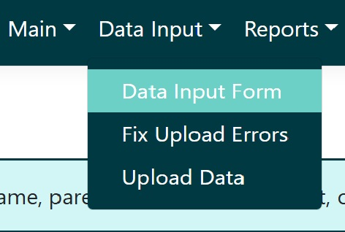

STEP 2 - For the drop-down menu labeled “fiscal year,” select the appropriate school year from the menu. The fiscal year is the same as the school year:

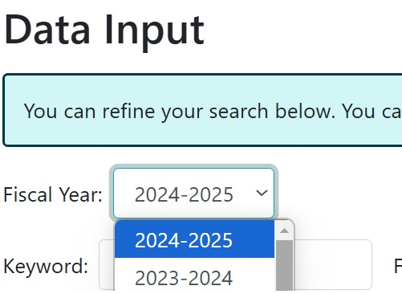

STEP 3 - Select your district and school from the list, and click the pencil icon under the “Actions” column:

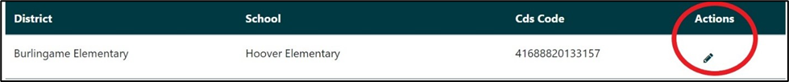

The SCOHR Data Input Form looks like this as of the 2024-25 school year, with 20 lines of data to enter—only the first 8 lines are shown in the image below:

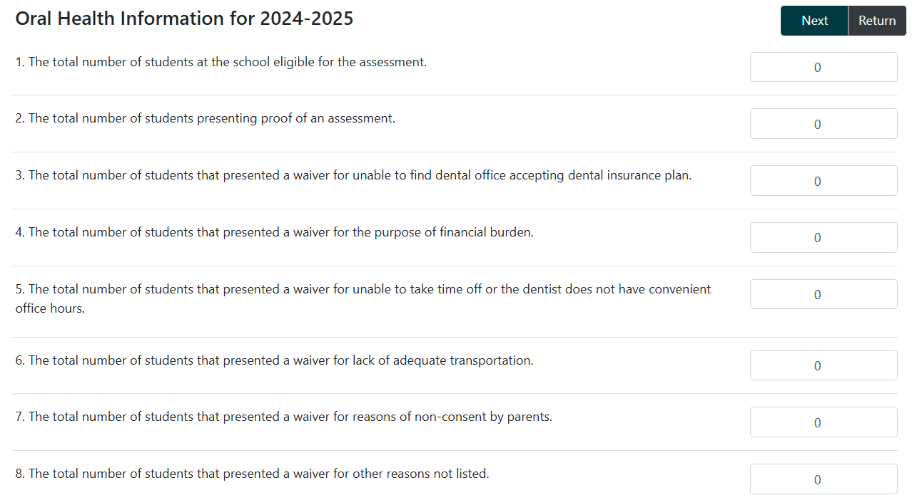

STEP 4 Enter the required data and press “Submit:”
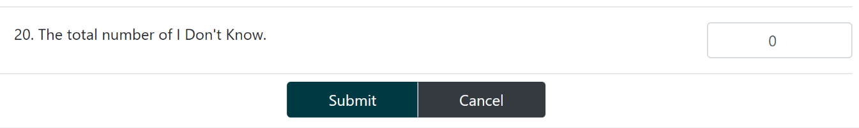

B. SCOHR Upload/Bulk Upload Function (aggregate level data)

The Upload Data/ Bulk Upload section in SCOHR can be used to upload data for multiple schools at one time, such as all schools in a district. There are 21 data fields required. This option has one more field required than the Data Input Form: the CDS code for each school. The data must also be uploaded in “.CSV” format (see more details below). To access this section in SCOHR, click the “Data Input” tab at the top of the menu bar. Then click “Upload Data.”

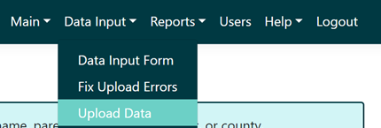

The data will likely first be entered for multiple schools into an Excel worksheet, following the “data schema format” required in SCOHR, which explains what data should go in each column:

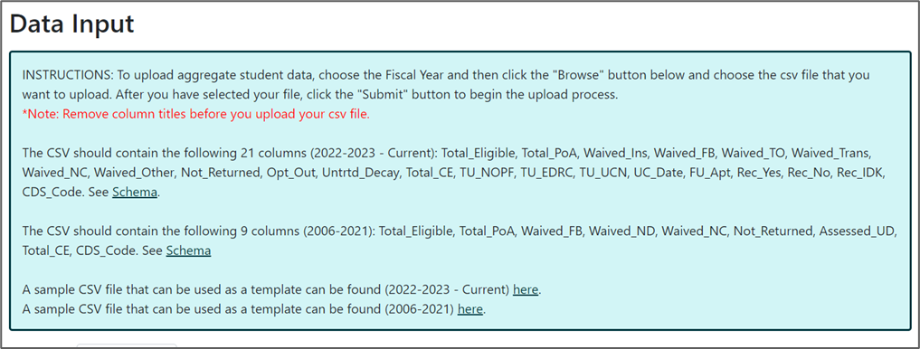

Before bulk uploading KOHA data to SCOHR, the Excel worksheet needs to be converted into (or “Saved As”) a “.CSV” file:

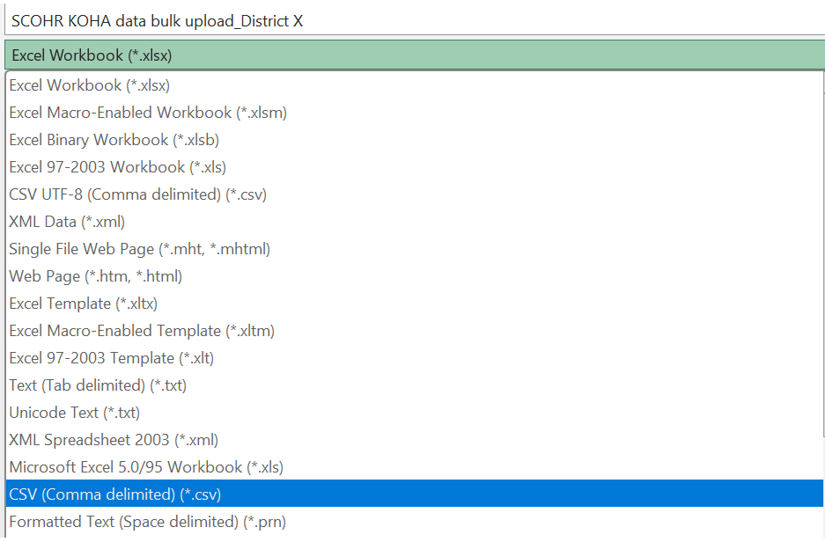

Once the .CSV file version is created, the .CSV file can be uploaded by selecting the correct school year (fiscal year) and clicking “Choose File.” Choose the .CSV file from the computer and submit by clicking the “Upload” button.
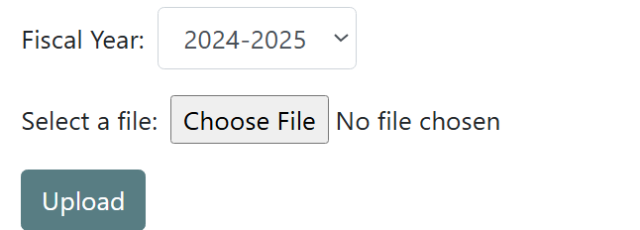

SCOHR will let you know automatically if there are any errors to fix. Follow the instructions to correct the errors.

Next, click on the “Fix Upload Errors” item in the drop down menu under “Data Input” to finalize your data and submit it. You need to click on this to finalize data even if there are no errors in your data.

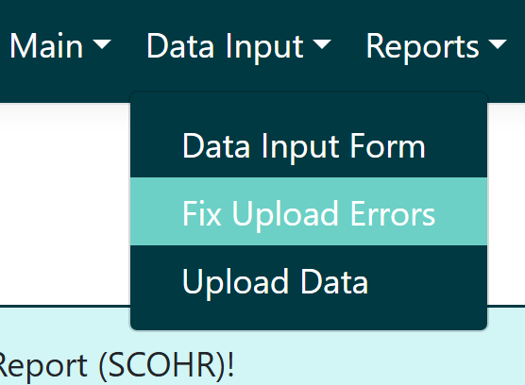

All uploaded and finalized data submitted into the database will now appear in the “Data Input Form” and “Reports” sections of the database.

Running Reports in SCOHR

KOHA Data Reports in SCOHR

Per the KOHA legislation, a KOHA data report must be sent to the County Office of Education by December 31st of the following school year (at the latest). Contact your Local Oral Health Program staff for assistance in creating a data report.

To download the raw data reports from SCOHR, go to the “Reports” section on the main menu, and select the report desired or available:

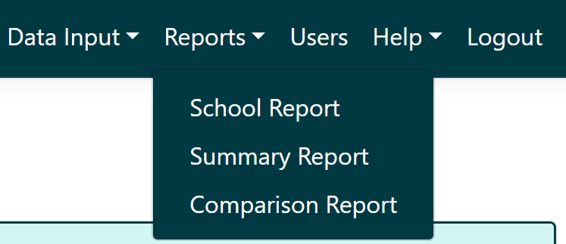

An easy- to- use Excel tool has been developed to allow you to copy and paste the data from the “Summary Report” into a worksheet, and it will automatically calculate key KOHA data for you in the subsequent tabs. Excel tabs are on the bottom of the page, and contain separate worksheets. Follow the Instructions on the first tab to use the tool. Key summary data includes:
- Percentage of students with untreated decay, caries experience, urgent dental care needs, and urgent dental care needs who received needed treatment
- Percentage of KOHA forms that are completed, waived, and not returned
- For waived forms: the reasons waived
- Percentage of schools entering completed KOHAs in SCOHR

Ways to Engage the COE and Other Partners with KOHA Data

LOHP staff can help with data reporting. The following are examples of key data that indicate the oral health status of students and can help drive conversations with partners about how to improve and prioritize oral health in schools and districts.

*Reminder: If your school enters data into SCOHR using the Quick Data Input Form, and uses the KOHA SCOHR Data Input Form Excel Worksheet to total that data, Tab 3 of that Worksheet will automaticallly summarize some of the key data below into tables and graphs.

General key KOHA data to consider reporting for the whole county, and for each district and/or school includes:

- Number and percentage of students eligible for KOHA who completed a KOHA screening

- Number and percentage of schools and districts reporting KOHA data in SCOHR.

- Number and percentage of students who completed a KOHA screening with untreated decay. Untreated decay is tooth decay (e.g., one or more cavities) that has not yet received treatment.

- Number and percentage of students who completed a KOHA screening with caries experience. Caries experience means a child has had tooth decay at some point in time. Caries experience covers both past treatment (e.g., fillings, crowns) and untreated decay at the present time (e.g., untreated cavities).

- Number and percentage of students who completed a KOHA screening with urgent dental care needs.

- Number and percentage of students with urgent dental care needs who received needed treatment.

Tips and Promising Practices for Implementing KOHA

Tips to Increase the Number of KOHA Forms Returned:

- Send the KOHA forms to parents/caregivers of incoming Transitional Kindergartners and Kindergartners before the summer break, so they can try to make a dental appointment during the summer.

- Emphasize forms should be returned as close to the beginning of the school year as possible, to discourage procrastination. Nurses and school staff have given feedback that they’d prefer the forms are turned in before the May 31st/ end of school year final deadline.

- Include KOHA reminders to parents/caregivers in existing reminders about other health paperwork required: immunizations, the first-grade health exam, vision, and hearing screenings.

- Utilize parent/caregiver communication tools like Peachjar, ParentSquare, or Student Information Systems to share the KOHA forms, flyers, and/or reminders with parents/caregivers.

- Make follow- up calls to parents/caregivers of children who have not returned the form. Aim for at least 3 follow ups to parents/ caregivers of children who have not returned the form.

- Include information about the oral health examination requirement on school and district webpages that have health requirements and/or registration requirements.

Tips from School Staff on Tracking KOHA Data:

- Include KOHA data in existing Student Information Systems (SIS). At a minimum, track which students have returned a completed form, waiver, and on-site screening opt-out letter in the SIS.

- Run queries from the SIS to get reports showing which students still need to submit the KOHA forms: “The Nurse and I enter the data from the oral assessment forms into Infinite Campus. Then run queries to get the data that is required for the report (SCOHR).” I also keep a hard copy of the KOHA forms in case I need to refer back to get any other data.” – School Admin Assistant

- If possible, work with IT to include all the data fields required in SCOHR (as of 2022) directly in the Student Information System. This will allow the required data to be entered directly into the SIS. Reports can then be run in the SIS, and used to enter the required data into SCOHR.

Tips on Conducting Follow-Up for Students with Urgent Dental Care Needs:

[Insert your local information about processes developed with schools or other care coordinators to provide care coordination and follow-up with students with urgent dental care needs]

Frequently Asked Questions (FAQs)

Q: What about Transitional Kindergartners (TK)- should they complete the KOHA?

In 2024, new legislation (AB 2630) clarified that for the purposes of KOHA, “Kindergarten” includes transitional kindergarten and kindergarten. The screening only needs to be completed once during this two-year kindergarten period.

Q: Can schools still use old forms?

No, the new form has additional information that the old forms do not have. This new information helps assure children with urgent care needs receive follow up. Also, the information on the new form aligns with data entry into SCOHR. There is an effort across the state to share information and use this information to address gaps in oral health care for students.

Q: Which school health evaluation is no longer required?

- As of July 1, 2024, the first grade health exam through the CHDP Program was discontinued. School-aged children are no longer required to have a physical exam before enrolling. However, the health examination is being recommended as an optional step for ensuring children’s health and readiness for school. CDE advised schools to update their enrollment processes to reflect these changes. Please direct any questions to CDE Office of School-Based Health Programs at OSBHP@cde.ca.gov.
- The Kindergarten Oral Health Assessment is still required, not optional. It must be completed by a licensed dental professional (dentist or dental hygienist), is only for public school students, and must be completed by transitional kindergartners or kindergartners, or first graders not previously enrolled in public school TK or kindergarten.

Q: On the KOHA form, what do untreated decay and caries experience mean?

- Untreated decay- Untreated decay is tooth decay (e.g., one or more cavities) that has not received treatment.
- Caries experience- Caries experience means that a child has had tooth decay at some point in time. Caries experience covers both past treatment (e.g., fillings, crowns) and untreated decay at the present time (e.g., untreated cavities).

Q: On the KOHA form, Section 2, what do the “treatment urgency” levels mean?

1-No obvious problem found - The child has no obvious dental problems and should continue to have routine examinations by their dentist every 6 months.
2-Early dental care recommended - The child has a tooth or teeth that should be checked by their dentist. They may benefit from sealants. The child’s parent/guardian should contact the child’s dentist, who will determine whether treatment is needed.
3-Urgent care needed - The child has a tooth or teeth that appear to need immediate care, as there is pain, infection, or swelling. The child’s parent/guardian should contact the child’s dentist as soon as possible for a complete evaluation.

Q: What if a child does not have a dental care provider or his/her family cannot afford an oral health assessment?

All children should obtain an oral health assessment from a licensed dental professional. If a child does not have a regular source of dental care or if their family cannot afford an oral health assessment, please see [insert information about local dental resources] or contact your child’s school for assistance. [If applicable for your county]: Many schools in [X] County offer free dental screening events and/or participate in school-based oral health programs. Parents can check with their child’s school to see if these services are available.

Q: What if a parent/guardian is unable to get an oral health assessment for their child?

The law recognizes that it may not be possible to get the required dental check-up for a child. On rare occasions, a parent/guardian may have their child excused from the requirement by filling out the Oral Health Assessment Waiver Form. To waive the assessment, the parent/guardian must identify on the form what prevented them from getting the dental checkup for the child (i.e. I am unable to find a dental office that will take my child’s dental insurance plan, or I cannot afford a dental check-up, etc.). This information is very important and must be included. The waiver request must be submitted by May 31st or the end of the school year (whichever date occurs first).

Q. What follow-up should we do, if any, for forms that are waived?

Please refer to above section titled: “Step 5: Waiver Forms”

FAQs and answers from COHTAC about KOHA:
KOHA FAQs

FAQS and answers from COHTAC about SCOHR:
SCOHR information and FAQs

Appendices
[Note: the page numbers here do not update automatically if edits are made]

Appendix A
Letter to the School Board 47

Appendix B
KOHA Timeline and Checklist for Schools 49

Appendix C.1
On-Site KOHA Screening Results Letter (English) 51

Appendix C.2
On-Site KOHA Screening Results Letter (Spanish) 53

Appendix D.1
KOHA Reminder Letter (English) 55

Appendix D.2
KOHA Reminder Letter (Spanish) 56

Appendix E
KOHA Flyer Example 57

Appendix F
SCOHR Infographic Example 58

Appendix A – Letter to School Board
[Direct link to this letter on COHTAC’s KOHA webpage]
[Insert date here]
Dear Board Member [insert first and last name here],

According to an expert at the Education Commission of the States, most children who drop out of school are “on that trajectory by the time they’re 8 years old.” I am writing to raise awareness about one of the factors that can put kids on that path — poor oral health. Children cannot learn when they are in pain, sleep- deprived or distracted because of tooth decay. The [name of school district] can do more to address this issue.

Years ago, California created the Kindergarten Oral Health Assessment (KOHA) to improve school readiness and raise families’ awareness of oral health’s importance. The percentage of children in [name of school district] who get a KOHA dental check-up is higher than the statewide average. That’s good news. Will you work with us to build on this progress, ensuring that all kids arrive at school healthy and ready to learn?

Consider what is at stake for our schools. Here’s what the education and health experts tell us:
- Poor dental health affects attendance and grades. Children with poor dental health are nearly 3 times more likely to be absent from school. Research has also found that California teens who recently experienced dental pain were about 4 times more likely to report lower grades.

- Many California children are affected. In a recent school year, 869,202 children missed school due to dental problems (2018 California Health Interview Survey, UCLA Center for Health Policy Research)
- Poor dental health drains school funding. The state Department of Education reported that dental-related absences has cost California’s public schools at least $60 million each year.
- This is about equity. We want all children to succeed. Unfortunately, the negative impact that absences have on learning is greatest among the most vulnerable students — low-income children and English language learners.

Tooth decay can occur at very early ages, and, if untreated, it can cause toothaches. By encouraging parents to have their kids screened, KOHA helps to identify and treat cavities before they become a more serious infection. This law has helped many parents find a “dental home” (dentist) for their children.
To make KOHA more of a priority, we need the support of you and your fellow board members. Will you meet with us to discuss ways for the district to raise its KOHA participation rate and collect data to monitor its progress? By working together, schools and local health advocates can promote dental health and put children on a path to better health and academic success.

We know our district has a lot of priorities on its plate. Still, we hope you will agree that KOHA is an approach worthy of the district’s time and energy.
[Insert a sentence indicating your availability and/or your willingness to work around the Board member’s schedule. If you are sending this as a snail-mail letter, be sure to provide your email address.]

Sincerely,
[Name, Title] [Organization]

Appendix B – KOHA Sample Timeline and Checklist for Schools
[Direct link to this timeline and checklist on COHTAC’s KOHA webpage]

Timeframe | Checklist Item | Notes
Fall to Winter of prior school year | ​​☐​ Include KOHA forms in kindergarten enrollment packets  Link to new KOHA forms in Eng. and multiple languages
Start of school year | ​​☐​ Distribute KOHA forms  Link to new KOHA forms in Eng. and multiple languages
August – end of school year or May 31st, whichever comes first | ​​☐​ Send reminders to parents/ caregivers about KOHA requirement and collect forms  [See Appendix D.1 and D.2 below.  Sample parent/caregiver KOHA reminder letter in English and Spanish  *Promising practice: aim to send at least 3 reminder calls or emails to parents/caregivers who have not turned in KOHA forms  ​​☐​ Use a system to track all required data from the forms for database entry  - KOHA Data Page  - KOHA SCOHR Data Input Form Excel Worksheet  - SCOHR Quick Data Input Form fillable PDF link
February: National Children’s Dental Health Month (NCDHM) and Give Kids a Smile (GKAS) events | ​​☐​ Send reminders to parents/ caregivers to complete KOHA during NCDHM and complete KOHA during GKAS events  Sample parent/caregiver KOHA reminder letter in English and Spanish
April-May | ​​☐​ Prepare for SCOHR data entry: Reach out to local oral health program staff or SCOHR staff if help is needed in obtaining or updating SCOHR usernames/passwords.  - SCOHR home page
End of school or May 31st – whenever school staff leave for summer break, and by July 1st at the latest | ​​☐​ Submit KOHA data into System for California Oral Health Reporting (SCOHR) database:  - SCOHR home page  - KOHA data page  - Detailed SCOHR User Manual  - SCOHR information and FAQs from COHTAC

Appendix C.1-On-Site KOHA Screening Results Letter (English)
[Direct link to this letter on COHTAC’s KOHA webpage]
(For parents and caregivers)
[insert organizational name/ logo here]
Oral Health Screening Results Letter

Child’s Full Name: Date:

Dear Parent or Guardian,

Your child received a dental screening at [insert school name] provided by licensed dental professionals from [insert organization] on [x date]. No x-rays were taken, and no treatments were given. The screening does not replace an in-office dental examination by your family dentist.

The results of the screening show:

_____ Your child has no obvious dental problems but should continue to have routine examinations by your family dentist every 6 months.

_____ Your child has a tooth or teeth that should be checked by your family dentist. Your dentist will determine whether treatment is needed.

_____ Your child has a tooth or teeth that appear to need immediate care. Contact your family dentist as soon as possible for a complete evaluation.

If your child needing emergency dental care does not currently have a dentist and/or dental insurance, [Include information about where to access emergency dental care in your county here].

Find a Medi-Cal Dental provider here:
[Optional: Insert county-specific information about how to access dental care]

[Optional: If your organization will be coming back to the school to provide this student with sealants, fluoride varnish, or other preventive services, information about that and the active consent form can be inserted here or somewhere else in this screening results letter]

Appendix C.2-On-Site KOHA Screening Results Letter (Spanish)
[Direct link to this letter on COHTAC’s KOHA webpage]
(For parents and caregivers)
[Insert organizational name/ logo here]
Carta de resultados de la evaluación de salud dental: PLANTILLA

Nombre completo del niño: Fecha:

Estimado padre, madre o tutor:

A su hijo se le realizó una evaluación dental en [insert school name], la cual fue realizada por dentistas profesionales de [insert organization] el [x date]. No se tomaron radiografías y no se le dio ningún tratamiento. La evaluación no sustituye las revisiones de su dentista familiar en el consultorio.

Los resultados de la evaluación indican:

_____ Que su hijo no tiene problemas dentales evidentes, pero debe seguir acudiendo con el dentista familiar para las revisiones de rutina cada 6 meses.

_____ Que su hijo tiene un diente o dientes que debe revisar su dentista de familia. Su dentista determinará si se necesita tratamiento.

_____ Que su hijo tiene un diente o dientes que parecen necesitar atención inmediata. Comuníquese con su dentista familiar lo antes posible para una evaluación completa.

Si su hijo necesita atención dental de emergencia y no cuenta con un dentista o seguro dental, [Include your organization’s hours and days for emergency dental care if applicable in addition to the ones listed here]

Encuentre un proveedor dental de Medi-Cal aquí:

[OPTIONAL: Insert county-specific information about how to access dental care]

[OPTIONAL: If your organization will be coming back to the school to provide this student with sealants, fluoride varnish, or other preventive services, information about that and the active consent form can be inserted here or somewhere else in this screening results letter]

Appendix D.1- KOHA Reminder Letter (English)
[Direct link to this letter on COHTAC’s KOHA webpage]
(For parents and caregivers)
[Insert logo in header]
Dear [Enter Your School's Name] Families of Kindergartners:

California law requires your kindergarten student—in transitional kindergarten or kindergarten--to receive an assessment of their oral health as part of school readiness activities for kindergarten entry. This requirement also applies to those first-grade public school students entering public school for their first year. An oral health assessment conducted the year prior to transitional kindergarten also satisfies this requirement. A dentist or dental hygienist must complete the form. The form is attached here: [Attach the KOHA form to this letter or provide a direct website link to it].

It should be completed and turned into the school at the beginning of the school year. If you have not yet turned in the oral assessment, please do so as soon as possible. You can make an appointment with your child’s dentist, and bring the form to the appointment so the dentist can complete it. Then, turn it into the school office staff.

As a reminder, all children should visit the dentist at least once every 6 months for a cleaning and a check-up/oral exam. These twice-yearly visits are covered by public and private dental insurance.

Thank you!
[Name, Title] [Organization]

Appendix D.2- KOHA Reminder Letter (Spanish)
(For parents and caregivers)
[Insert logo in header]
[Direct link to this letter on COHTAC’s KOHA webpage]
Estimadas familias de niños del kínder de [Enter Your School's Name]:

La ley de California requiere que su estudiante del kínder—en kínder de transición o kínder--reciba una evaluación de la salud oral como parte de las actividades de preparación escolar para ingresar al kinder. Este requisito también se aplica an aquellos estudiantes de primer grado de escuelas públicas que ingresan a la escuela pública para su primer año. Una evaluación de salud oral realizada el año anterior del kínder de transición también cumple con este requisito. Un dentista o un higienista oral debe completar este formulario. Se adjunta el formulario [Attach the KOHA form to this letter or provide a direct website link to it].

Debe completarse y entregarse a la escuela al comienzo del año escolar. Si no ha entregado la evaluación oral, por favor hágalo lo antes posible. Puede programar una cita con el dentista de su hijo y llevar el formulario a la cita para que el dentista pueda completarlo. Luego, entréguelo al personal de la oficina de la escuela.

Como recordatorio, todos los niños deben visitar al dentista al menos una vez cada 6 meses para una limpieza y un chequeo/examen bucal. Estas visitas bianuales están cubiertas por seguro dental público y privado.

¡Gracias!

[Name, Title] [Organization]

Appendix E – KOHA Flyer Example
[Direct link to the editable Canva KOHA Flyer document here]

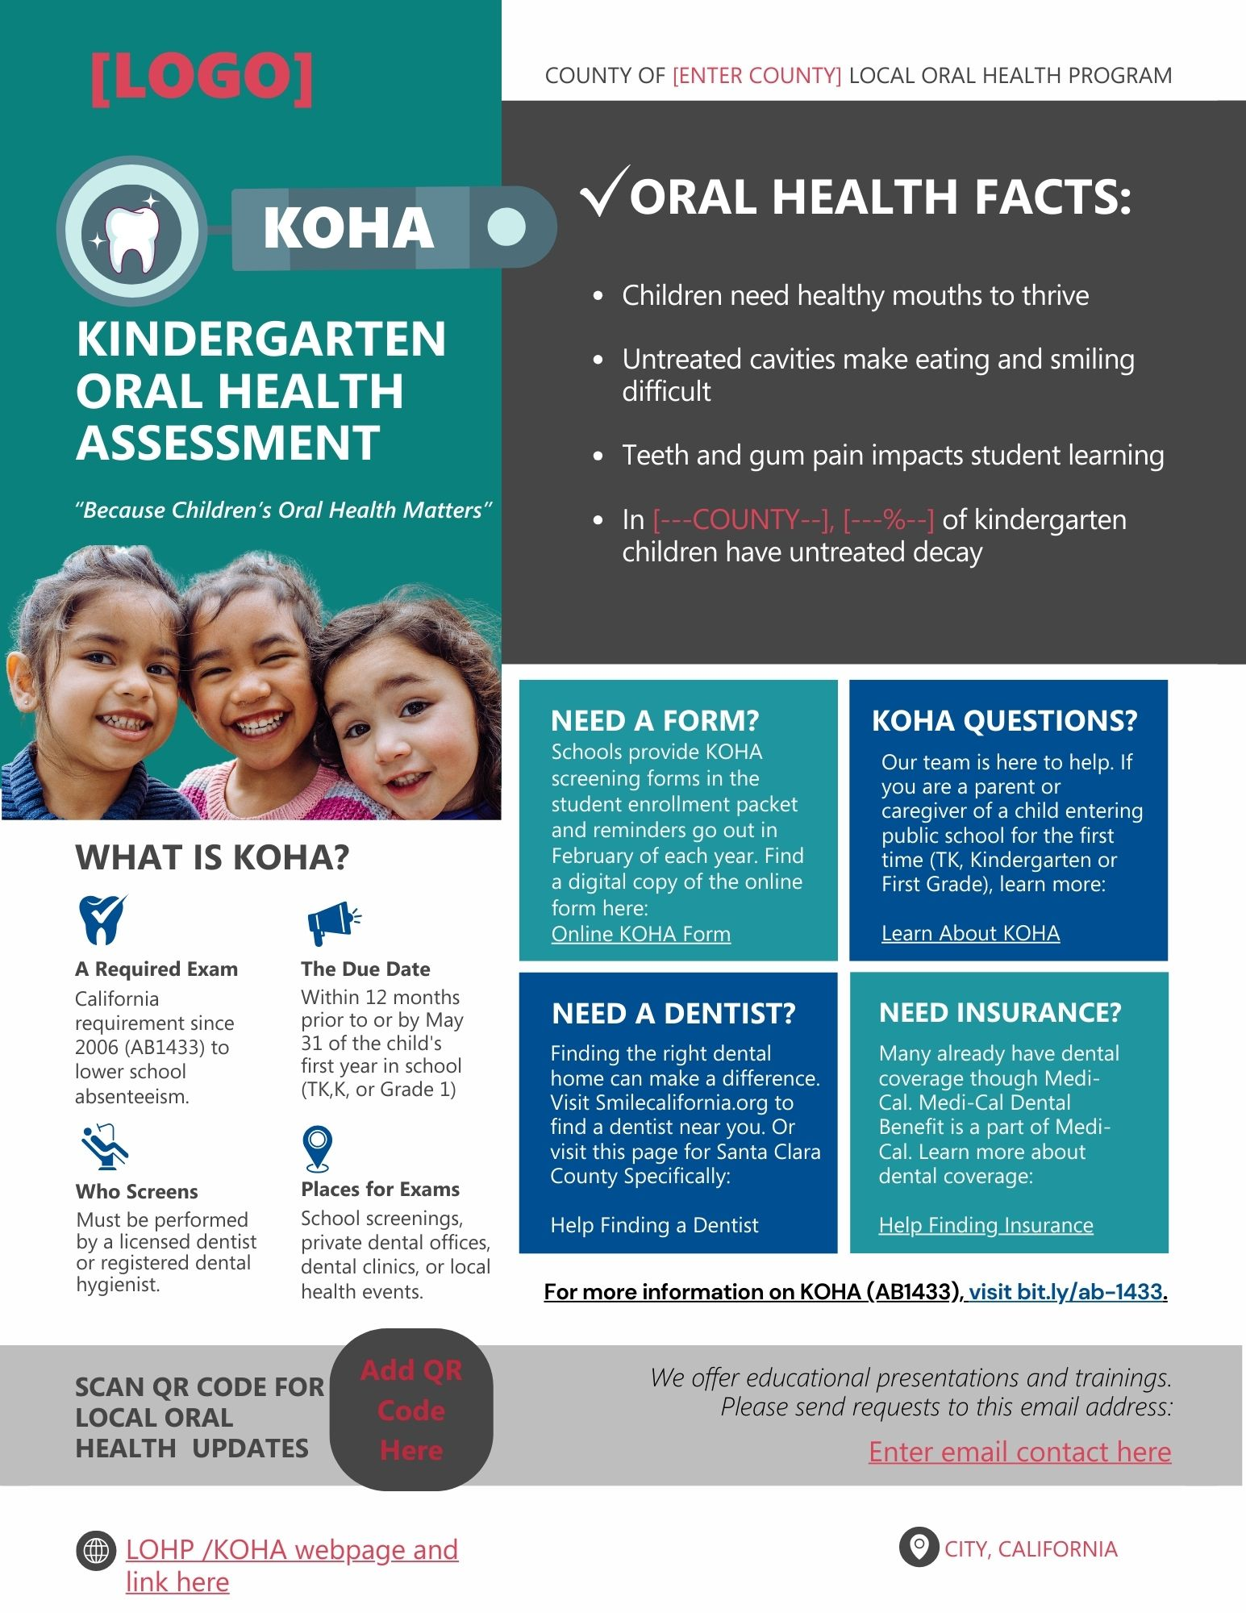

Appendix F – SCOHR Infographic Example

[Direct link to the editable Canva SCOHR Infographic document here]

