Social Media Request Template:
Use this template to submit your social media request including post copy and graphics. Refer to the Social Media Best Practices Guide for additional guidance, insight, and examples.

Platform(s): Facebook, Instagram, X, Bluesky  Desired post date: Week of 2/2  Copy:  February is National Children’s Dental Health Month! A healthy smile starts with simple daily habits:  - Brush teeth twice a day with toothpaste that has fluoride  - Brush for a full two minutes  - Drink tap water that contains fluoride to prevent tooth decay  - Visit your dentist regularly and ask about fluoride varnish  Find more tips and find a dentist at smilecalifornia.org.  #NCDHM #BrightSmiles #HealthyHabits  X/Bluesky copy:  February is National Children’s Dental Health Month! Remind kids:  - Brush twice a day with toothpaste with fluoride  - Brush for 2 minutes  - Drink tap water with fluoride to prevent tooth decay  - Visit your dentist regularly and ask about fluoride varnish  smilecalifornia.org | Graphic/link to final video (if available):  Love Your Teeth w logo.jpg  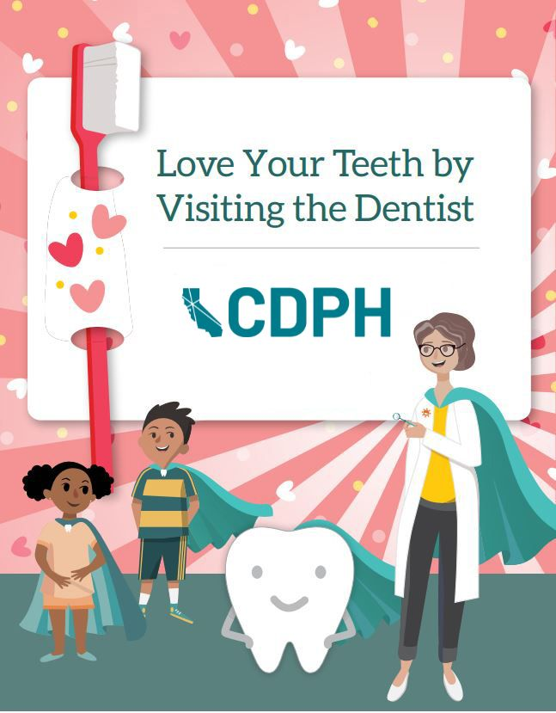
Describe what design details (tone, audience, colors) you’re requesting in the graphic: | Sample graphics or inspiration photos (optional):

